|  |
| --- |
| David Asare |

Humber College Institute of Technology & Advanced Learning DeepRacer Entry 0NB

Status

/1 Hardware present?

/1 Title Page

/1 Declaration of Joint Authorship

/1 Proposal (500 words)

/1 Executive Summary

# Declaration of Joint Authorship

We, Student A, Student B, and Student C, confirm that this work submitted is the joint work of our group and is expressed our own words. Any uses made within it of the works of any other author, in any form (ideas, equations, figures, texts, tables, programs), are properly acknowledged at the point of use. A list of the references used is included. The work breakdown is as follows: Each of us provided functioning, documented hardware for a sensor or effector. Student A provided __. Student B provided ___. Student C provided ____. In the integration effort Student A is the lead for further development of our mobile application, Student B is the lead for the Hardware, and Student C is the lead for connecting the two via the Database.

# Proposal

We have created a mobile application, worked with databases, completed a software engineering course, and prototyped a small embedded system with a custom PCB as well as an enclosure (3D printed/laser cut). Our Internet of Things (IoT) capstone project uses a distributed computing model of a smart phone application, a database accessible via the internet, an enterprise wireless (capable of storing certificates) connected embedded system prototype with a custom PCB as well as an enclosure (3D printed/laser cut), and are documented via this technical report targeting OACETT certification guidelines.

Intended project key component descriptions and part numbers  
Development platform:   
Sensor/Effector 1:   
Sensor/Effector 2:   
Sensor/Effector 3:

We will continue to develop skills to configure operating systems, networks, and embedded systems using these key components to ____________. _____________________________________________. _________________________________________________.

Our project description/specifications will be reviewed by, _____, ideally an employer in a position to potentially hire once we graduate. They will also ideally attend the ICT Capstone Expo to see the outcome and be eligible to apply for NSERC funded extension projects. This typically means that they are from a Canadian company that has been revenue generating for a minimum of two years and have a minimum of two full time employees.

The small physical prototypes that we build are to be small and safe enough to be brought to class every week as well as be worked on at home. In alignment with the space below the tray in the Humber North Campus Electronics Parts kit the overall project maximum dimensions are 12 13/16" x 6" x 2 7/8" = 32.5cm x 15.25cm x 7.25cm.

Keeping safety and Z462 in mind, the highest AC voltage that will be used is 16Vrms from a wall adapter from which +/- 15V or as high as 45 VDC can be obtained. Maximum power consumption will not exceed 20 Watts. We are working with prototypes and that prototypes are not to be left powered unattended despite the connectivity that we develop.

# Executive Summary

Explain what accomplishments are described by this document and why your product should be purchased and you should be hired by an investor.

Contents

Declaration of Joint Authorship 3

Proposal 5

Executive Summary 7

List of Figures 11

1.0 Introduction 13

1.1 Scope and Requirements 14

2.0 Background 17

3.0 Methodology 21

3.1 Required Resources 21

3.1.1 Parts, Components, Materials 21

3.1.2 Manufacturing 23

3.1.3 Tools and Facilities 24

3.1.4 Shipping, duty, taxes 26

3.1.5 Time expenditure 27

3.2 Development Platform 28

3.2.1 Mobile Application 28

3.2.2 Image/firmware 30

3.2.3 Breadboard/Independent PCBs 30

3.2.4 Printed Circuit Board 32

3.2.5 Enclosure 33

3.3 Integration 34

3.3.1 Enterprise Wireless Connectivity 35

3.3.2 Database Configuration 35

3.3.3 Security 35

3.3.4 Testing 35

4.0 Results and Discussions 37

5.0 Conclusions 39

6.0 References 41

7.0 Appendix 43

7.1 Firmware code 43

7.2 Application code 43

# List of Figures

Figure 1. By Android Studio - https://developer.android.com/studio/, CC BY-SA 4.0, https://commons.wikimedia.org/w/index.php?curid=74094999 29

Figure 2. Initial schematic. This work is a derivative of "http://fritzing.org/parts/" by Fritzing, used under CC:BY-SA 3.0. 31

Figure 3. This work is a derivative of "http://fritzing.org/parts/" by Fritzing, used under CC:BY-SA 3.0. 31

Figure 4. Breadboard prototype. 32

Figure 5. PCB design This work is a derivative of "http://fritzing.org/parts/" by Fritzing, used under CC:BY-SA 3.0. 33

Figure 6. Humber Sense Hat Prototype PCB. 33

Figure 7. Example enclosure. 34

# Introduction

Self-driving cars are very closely associated with industrial for IoT. Self-driving cars are combined by IoT with other technologies such as local computing, machine learning etc. Which is providing the required technologies for self-driving cars. The most challenging question for self-driving cars is how it is functioning. The control of the wheel is a must. There can be something working inside to make the car work without the wheel. A lot of the sensors, actuators, motors, and controllers are equipped with the car these days. Explanation of surrounding environment and possible changes to those surroundings is one of the main tasks of any machine learning in self-driving today.

The product we will be working on is called the Mini Robot Rover. The idea is to make a control car than can be controlled using an Android cellphone app, with an implemented camera to the car. Whatever the camera sees, should output the display on the phone screen. As the car moves, speed and distance should be displayed as well.

The software we are using to make the application, is Android Studio written in Java. The code to program our sensors and motors are written in Python. The 2 motors which will be used for this project to control the Mini Robot Rover is micro servo body. There will be the importance of the motor driver chip which is L293D, and why it is needed for the project to correctly function. I will talk about the wire connections, and which pins of the GPIO is needed to connect the CPU.

The motor driver chip name of the component for moving motors forward and in reverse is Motor Driver L293D. This chip will function when it is connected to the PCB and it shows the movement of the motors on either direction. The 5 volts can be used from the raspberry pi. The pin 2 is a VCC pin which supplies 5 voltage from raspberry pi to make the motors work. We also have an option to use 4x AA batteries to make the motors work as well. L293D is a 16-pin IC which can control a set of two DC motors simultaneously in any direction. It means that you can control two DC motor with a single L293D IC. There are 4 input pins for l293d, pin 2,7 on the left and pin 15 ,10 on the right. Left input pins will regulate the rotation of the motor connected across left side and right input for motor on the right side. The data of the 2 motors will be on the raspberry pi. The firebase and pyre base are going to be used to send the data of the 2 motors to the software app. Therefore, it can be used for the app controls to move the car when it is built. At the end of the semester our project will be combined and ready with the sensors and motors to make it transform into a smart control car.

## 1.1 Scope and Requirements

This is an Internet of Things (IoT) capstone project that uses a distributed computing model of a smart phone application, a database access using Firebase, and a Raspberry Pi (RPI) circuit board along with the enclosure design (3D printed/lasercut). We will also merge our 3 PCB boards to be one custom PCB. One of the limits we have for this project is that the RPI circuit board cannot be powered with over 5 volts. Using a maximum of 5 volts is just what we need for our project to be successful.

Hardware Specifications:

* Raspberry Pi (5 volts max).
* PCB Design (Merged).
* Enclosure Design (Protection case for RPI).
* Control Car Parts (Built).

Android Device Requirements:

* Android 2.2 or Higher
* Average WIFI Connection

Database Specifications

* Firebase and Pyrebase Completed.
* Users email and password will be stored into the database.
* User should login and be given a unique id.
* User Authentication
* Real-time database
* Hosting

Report

/1 Hardware present?

/1 Introduction (500 words)

/1 Scope and Requirements

/1 Background (500 words)

/1 References

# 2.0 Background

Humber has launched a Deep Racer League project which also has to do with a control car. The Deep Racer project uses skills in cloud computing, and our project of the Mini Robot Rover uses skills in Computer Engineering Technology. Since these projects are using a control car, it is possible add more ideas to our project from the Deep Racer, and the Deep Racer team to add ideas from our Mini Robot Rover project.

Skills in cloud computing have become most essential in the modern workforce and Humber College is taking steps it hopes will help fill the talent gap in Canada. (Buckley, S,2019,p.1)

Humber will be launching its Cloud Computing Ontario Graduate Certificate in the fall of 2020, and will be in the partnership of Amazon Web Services (AWS).

Through this partnership, Amazon will be providing Humber with its cloud infrastructure as well as many of the cloud computing tools being used in the course. Such tools include the AWS Deep Racer, a 1/18th scale race car driven by reinforcement learning, and ‘go smart with Alexa’, an AI training program that creates custom Alexa skills using Amazon Echo. (Buckley Smith, 2019 p.5).

Amazon Echo is a hardware lineup of Bluetooth speakers, displays and alarm clocks. They are all powered by Alexa which is Amazons voice personal assistant that listens and responds to what you ask it to do.

Thanks to Alexa, Amazons Echo devices can play music, read the news or an e-book or an audiobook, report weather and traffic conditions, recite sports scores and schedules, call a ride, shop, check your bank account, give movie schedules, check your calendar, set a timer, tell jokes, host a game right night and answer questions. It can also connect to your smart home devices. Many of these things will work right out of the box, but you can get the Echo to do even more by enabling Skills. (Kozuch, K, 2019 p.10).

The Deep Racer team wants their control car to have many functions, which is why they are making it work with Alexa and Amazon Echo. Artificial intelligence is also advancing as the years go by. Humber College is about to become an AWS Academy Institution. It will use an AWS Certification Testing Center, which allows teachers to teach the AWS curriculum and explain the testing needed for AWS certification.

When we first came up with our project of the Mini Robot Rover, we found out that the car parts can be built with any mounted circuit board, with sensors added to it. The car parts came with wheels, DC motors, Support Wheel Metal Chassis and Top Metal Plate with mounting hardware. All that was left was for us to use our creativity on what we want the car to do, which is why we chose the Ultrasonic Distance Sensor, and Speed Sensor to work with the Raspberry Pi Circuit board. Just like the AWS Deep Racer project, many ideas can also be added to the Mini Robot Rover project.

**References**

Smith, B. (2019), p.1. Retrieved from:

<https://business.financialpost.com/technology/tech-news/humber-college-launching-cloud-computing-certificate-in-partnership-with-aws>

Kozuch, K. (2019) Retrieved from: <https://www.tomsguide.com/us/amazon-echo-faq,review-3377.html>

Smith, B. (2019), p.5 Retrieved from:

<https://www.itbusiness.ca/news/humber-college-launching-cloud-computing-certificate-in-partnership-with-aws/113168>

Engineered in NYC Adafruit (2019) Retrieved from:

https://www.adafruit.com/product/2939

# 3.0 Methodology

## 3.1 Required Resources

Report

/1 Parts/components/materials (500 words)

/1 PCB, case (500 words)

/1 Tools, facilities (500 words)

/1 Shipping, duty, taxes (250 words)

/1 Working time versus lead time (250 words)

### 3.1.1 Parts, Components, Materials

For this project, the Mini Robot Rover control car parts are required to be built so we can attach the Raspberry Pi to the control car. This project requires safety glasses, the Ultrasonic Distance Sensor, Speed Sensor, Motors, resistors, L293D Motor Driver, breadboard, Kuman camera and a cell phone to control the car.

The cell phone we currently have is the Motorola Moto G7. The G7 is able to cram a 6.2-inch display into a similarly sized body. It has a dewdrop notch which helps to bring the screen closer to the edges which have bezels thinner than those on the iPhone XR. The display has a nice contrast and looks good in many situations. This phone has a 12-megapixel main camera and a 5-megapizel depth camera. This offers a solid camera experience.

The Kuman camera for the Raspberry Pi circuit board. Has a 1080p OV5647 Sensor HD Video Webcam which supports night vision for all Raspberry Pi models. This is what we will use to mount on the control car. The weight of this camera object is 18.1g. This component is possibly to be implemented depending on the reliability of the project.

The Ultrasonic Distance Sensor HC-SR04 (45mm x 20mm x 15mm) component will be used to measure the distance when the Vcc, Trig, Echo, and Ground pins are connected. This component requires a 4-pin header, along with the 2 resistors which are 1k, and 2k ohms to be connected to the PCB board.

The Speed Sensor module (32mm x 11mm x 20mm) is used to measure high speed rotation counting as the car moves. The LM393 chip registers the break and adjusts the output signal to notify the user. This sensor has 3 pins for 3 connections for ground out and Vcc and can be used with jumper wires.

The Mini Robot Rover car parts come with 2x Wheels, DC Motors in MicroServo shape, 1x Support Wheel, Metal Chasis and Top Metal plate with mounting hardware. These parts will be used to build the control car and make space for the Raspberry Pi connection.

The Raspberry Pi 4 (RPI 4) is what we will be using for this project. The RPI 4 Model B is the latest product in the popular Raspberry Pi range of computers. It offers huge increases in processor speed, multimedia performance, memory and connectivity compared to the prior generation of the Raspberry Pi 3 Model B+. This circuit board can be used to power up the sensors you work on for a project. The recommended power for this board is 3 to 5 volts. The main computer language written for the RPI is Python.

The L293D Motor Driver is an IC component which will be important for the project, because it will help with the movement of the car, when it’s connected to the 2 motors. This is a 16-pin IC and works on the concept of an H-bridge. In a single L293D chip there are two H-bridge circuits inside the IC which can rotate two dc motors independently. Due to its size, it is very much used in robotic applications for controlling DC motors.

### 3.1.2 Manufacturing

PCB is an acronym for printed circuit board, which mechanically supports and electrically connects electrical or digital factors the use of conductive tracks, pads and different points etched from one or greater sheet layers of copper laminated onto and or between sheet layers of a non-conductive substrate. Components are generally soldered onto the PCB to both electrically join and robotically fasten them to it. For our final project of the capstone project we are making a smart control car. The name of our smart control is the Mini Robot Rover. The idea is that we combine our 3 components or devices which will operate as one custom PCB. The combination of the three components are: LM393 speed sensor, HC-SR04 ultrasonic distance sensor, and motor driver (L293d) with 2 motors. The PCB will be created by using the Fritzing software and will be printed out at the prototype lab. We highly recommend for everyone in the future to troubleshoot using cold testing. The cold test should be an important requirement before plugging in the PCB to the raspberry pi. The cold test meaning is that using a multimeter to test the soldering points of each connectivity to find out if it is 100% successfully connected. A multi meter is required to test the PCB to see if than can be any voltage connections running through the copper wires. When the PCB is printed and it is ready to go, we have to connect all of our sensors and effectors. Then we solder all of them, depends on where the soldering points supposed to be connected and where the points should be soldered completely. Once all of that is completed the PCB will be safe to connect on the Raspberry Pi for testing. The Multi-meter can be used to measure the resistance of the resistors, making sure they are the correct components for the PCB. This is to make sure that there is no short circuit that can affect or damage the sensor or the PI. One of the benefits of a PCB board is that all wire connections can be made on just one flat board, which can save a lot of space in an object.

We are going to design our case using the CorelDraw software. We will design our enclosure as 3D printed or as laser cut. The CorelDraw software is used create the design of the enclosure. The enclosure is a case that surrounds a Raspberry Pi CPU keeping the hardware safe and secured. We would measure the dimensions of our PCB with our Raspberry Pi and create the enclosure on CorelDraw with all correct dimensions. The design of our enclosure will vary, depending on the size of the PCB. Since, our PCB and enclosure design case has not been created as of yet, it will take hard work and dedication for our project to put everything together to get it all completed and ready for testing. Our smart control car would be would be sold in any market, the price will depend on the manager or customers.

### 3.1.3 Tools and Facilities

The tools used is the screw driver, screws, bolts, Multi-meter with lead wires to measure voltage and resistance, Soldering Iron Kit and soldering wire. The facilities used is the Humber prototype lab.

The Multi-meter is an electronic measuring device that combines multiple measurement functions in one unit. Multi-meters are capable of many different readings, depending on the model. The testers measure voltage, amperage, and resistance and can be used to check continuity, a simple test to verify a complete circuit or PCB board. Advanced Multi-meters may test for values like Alternating Current, Direct Current, Resistance, Capacity, Conductance, Decibels, Duty cycle, Frequency, Inductance, and Temperature. When testing a PCB board with the Multi-meter, we can put it on a beep setting mode to see if current is passing around the board. If the Multi-meter beeps, it means current is passing through the board. If it does not beep, then there is no current.

The soldering iron is a tool with a metal tip that can heat up to about 800 degrees Fahrenheit, but the temperature is adjustable. This tools job is to transfer heat to things like wires, transistor leads, and pads on PCB boards. After the important areas are heated properly, solder is applied. A good soldering kit can be brought for $30 to $40, which will give you a longer lasting tool that will work for a much wider variety of applications, with proper heat control to boot. There are also soldering guns available, but they are only used to repair thick cables and never on PCBs. When soldering, we must be sure to wear safety glasses, keep loose clothing and hair out of the way, and be careful with your fingers. Protective gloves can also be used when soldering.

Solder is a thin tube, usually rolled and made of various metal. It is used to hold the individual components together. For computer electronics, we are usually looking at 60% thin and 40% lead. Lead free solder is also available, but it has higher melting temperatures, meaning a better soldering iron will be needed in order to remove it. Lead-free solder is better for the environment and has more benefits. A wet sponge also comes in handy to wipe off the solder after the iron is heated up. This will help with cleaner and faster soldering on a PCB board.

The Humber prototype lab is a room with many tools and equipment that can be used for Computer Engineering and Electronics Engineering students to complete capstone projects. The prototype lab also has 3D printers, and laser cut printers. This can help us to adjust any specific measurements we need to properly fix the project. Teachers in the prototype room can also show you the best software to use, depending on what kind of project you are working on and may have ideas on how you can improve on your project. They can teach you how to use software like Corel Draw to print a laser cut case and Fritzing to make an organized and connected PCB board.

### 3.1.4 Shipping, duty, taxes

The Ultrasonic Sensor was purchased for a pack on Amazon for $11.59 with free shipping. It can be shipped to your location the next day after purchase. There are a few shipping options for Amazon which are, Standard Shipping for 3 to 6 business days, Express Shipping for 2 to 4 business days and priority shipping for 1 to 3 business days. 1-day shipping is what we used. The Raspberry Pi 4 was purchased for $90 and can only be returned within the first 30 days of purchase. The Speed Sensor has a price of $2.50 with a shipping time of 30 days, but an option to purchase it for $30 for a shipping time of 3 days. It was brought from the website pihut.com. If within 14 days of your purchase you decide you aren’t happy with the product you can ship it back to them for a refund. The Mini Robot Rover Chasis kit – 2WD with DC Motors comes with a price of $24.95. It is sold from the site adafruit.com and takes 2 to 3 weeks to arrive after purchase. This site has many distributors like EXP-Tech, Chicago Electronic Distributors, The Pi Hut, Core Electronics, S.O.S Solutions, Kiwi Electronics and Makersify. These are the sites and companies Adafruit works with in order to sell electronic parts that can be used for a project. Adafruit has 3 shipping options such as, USPS (United States Postal Service), UPS (United Parcel Service) and DHL (Dalsey, Hillblom and Lynn). USPS is usually cheaper and does not provide detailed tracking. For domestic orders, UPS is sometimes faster and a little more expensive, but has a high-quality tracking system. The tracking information is emailed when the package is shipped. When in doubt of choosing a shipping method on Adafruit, DHL or UPS are recommended. DHL is available to many countries worldwide across the globe. If DHL shipping is available in your location, the option will show at checkout.

### 3.1.5 Time expenditure

We will have work time and lead time for this project. We have our Computer Systems Project course 3 hours every week and will come out with a total of 56 hours by the end of the semester when the project is completed. During our 3-hour course, we will use that time to work on our project by building the control car and putting all of are purchased parts, components and materials to use. Outside of our Computer Systems Project course, we will have the rest of the week to continue to develop our user interface design in our mobile application and making the app easier to understand for anyone using it. This time can also be used to work on our reports and come up with ideas on how to improve on our project. With our lead time, our total will be more than 56 hours when we include the time working on the project outside of the class. Some of the components we purchased like the Speed Sensor, is also sold on Amazon and can take 15 to 20 days to be shipped from China to Canada since the speed sensor module takes a few days to manufacture and build. The speed sensor comes from a Chinese company called All Dazzling. The Distance sensor is sold by a company called SunFounderCA. They have sold products in many countries like the United States, Germany, Canada, the United Kingdom, France, Italy, Spain, Japan, etc. They have a pack of products that are ready and made to be sent to your location after 1 day of purchase.

## 3.2 Development Platform

In this section I will talk about the development platform of our mobile application and the details of how we made our android app.

### 3.2.1 Mobile Application

I will explain how we made our Mobile application, along with login activity, data visualization activity and action control activity. I will also talk about what software we used to plan how we wanted our Mobile app to look and what language we used to make the actual Android application.

Before we made the Mobile Application, we used the mockup software to plan how we want our android app to look. Mockups are one of the most effective ways of communicating visual requirements clearly. Making decisions about fonts, color schemes, brand assets, content layout and navigation pattern styles will be worked out on a mockup screen. That way, we can have a good idea of what we want our Mobile app to look like when we create it. With the mockup design, you may also be able to realize what User Interfaces you may want, or don’t want when you create the android app. This will help us make our Mobile app in a more organized fashion.

After our mockup design was complete, we used Android Studio to make our Mini Robot Rover Mobile application. Android studio is the official integrated development environment for Googles Android operating system. This software is specifically designed for Android development and is available for download on Windows, macOS and Linux based operating systems. It is written using Java and XML. We used Java for the Android functions and XML for the User Interface design.

We created the app in a way that the user should be able to successfully register an account and login, to be directed to the control buttons page. When the user is logged in, they should see a welcome page that gives some information on how the app works. They will then be directed to a short instructions page which will show them how to move the car. The user should have access to all the product functions when they are connected on a WIFI network with access to the internet.

We made the welcome page using XML. We added a picture to that page by downloading a picture from google images and putting it in the drawable folder. That way we were able to drag the picture setting to the android page and add the picture we downloaded. In XML it’s called ImageView. The 2 buttons on that page are the next button and the skip button. The next button turns to the next page of the app and the skip button skips to the last page of the app. This is done using intent functions in Java, which allows you to click and load from one page to another. We also have the color green for most of our pages on the app.

After the welcome page, we have the instructions page. The paragraph of instructions was made using the XML TextView, where the written paragraph was saved as a string. This helps to save space in the code since the paragraphs will be stored in the strings.xml file. To get an image icon for the app, we downloaded an image and opened it in the app as an image asset.

For the login activity, we used Firebase SDK Authentication for logging users into the application. This is used to authenticate users with their email address and passwords. The Firebase Authentication SDK provides methods to create and manage users that use their emails and passwords to sign in. It also handles sending password reset emails. After the user signs in for the first time, a new user account is created and linked to the credentials the user signed in with. This new account is stored as part of the Firebase project, and can be used to identify a user across every app in our project. In the Firebase Realtime Database and Cloud Storage Security rules, we can get the signed in users unique id from the auth variable and use it to control what data the user can access.

For the Data visualization activity, we have our file Controls.xml to show the control buttons for the car as arrows with speed and distance showing at the top. The arrows will be used for forward, backward, left, right and stop. This is the main page for our android application, where the Mini Robot Rover will be controlled from. So far, we can click the arrows and display speed and distance at the top so it shows information like a virtual control car.

For the Action control activity, we have Java functions for direction, motion and roverName set in the firebase. The app will separate forward and back motion (throttle) from the left and right motion (direction). When forward is pushed, the app will notify firebase that forward is pushed and this will remain until a stop action or another throttle or direction is pushed by the user. Updating rpm and direction from firebase is loaded by the app. The simulator can read the user actions and fake the position of the rover. In our Controls.java file, we also have an onClickListener to process which button was pressed and an Event Listener to process when the button was pressed by the user. This is how we made our Mobile application.

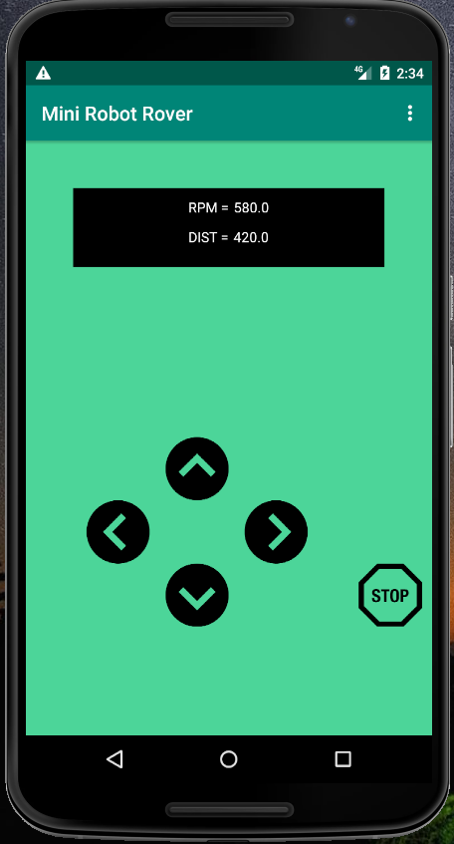

Figure 1. Mini Robot Rover Mobile Application

Status

/1 Hardware present?

/1 Memo by student A + How did you make your Mobile Application? (500 words)

/1 Login activity

/1 Data visualization activity

/1 Action control activity

Include screenshots such as Figure 1. Testing. Progress.

### 3.2.2 Image/firmware

Status

/1 Hardware present?

/1 Memo by student B + How did you make your Image/firmware? (500 words)

/1 Code can be run via serial or remote desktop

/1 Wireless connectivity

/1 Sensor/effector code on repository

### 3.2.3 Breadboard/Independent PCBs

Status

/1 Hardware present?

/1 Memo by student C + How did you make your hardware? (500 words)

/1 Sensor/effector 1 functional

/1 Sensor/effector 2 functional

/1 Sensor/effector 3 functional

The initial schematic design, Figure 2, based on datasheets (Bosch Sensortec, 2019) led to a breadboard layout Figure 3 that was realized Figure 4.

How did you build your Prototype: Breadboard?

Then a PCB was designed, Figure 5, and populated (Figure 6). Bill of Materials, Case, Time commitment. Testing. Progress.

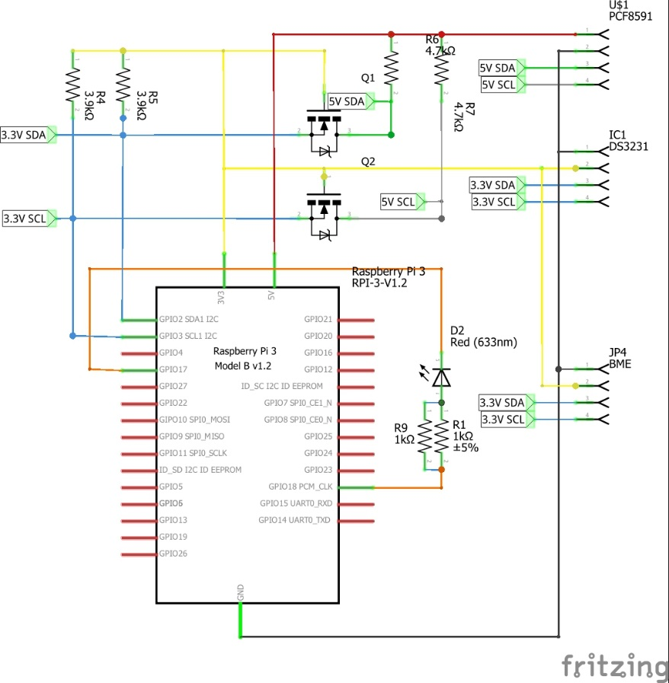

Figure 2. Initial schematic. This work is a derivative of "http://fritzing.org/parts/" by Fritzing, used under CC:BY-SA 3.0.

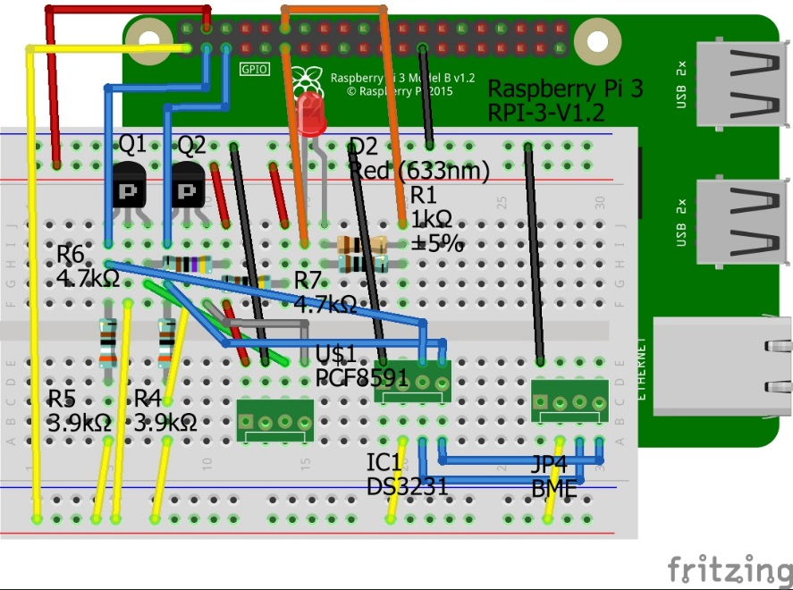

Figure 3. This work is a derivative of "http://fritzing.org/parts/" by Fritzing, used under CC:BY-SA 3.0.

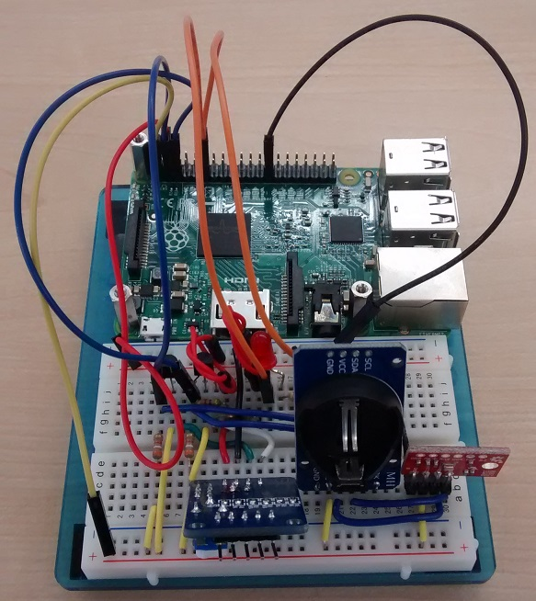

Figure 4. Breadboard prototype.

### 3.2.4 Printed Circuit Board

Demo

/1 Hardware present?

/1 PCB Complete and correct

/1 PCB Soldered wire visible but trim, no holes or vacancies

/1 PCB Tested with multimeter

/1 PCB Powered up

How did you build your Prototype: PCB?

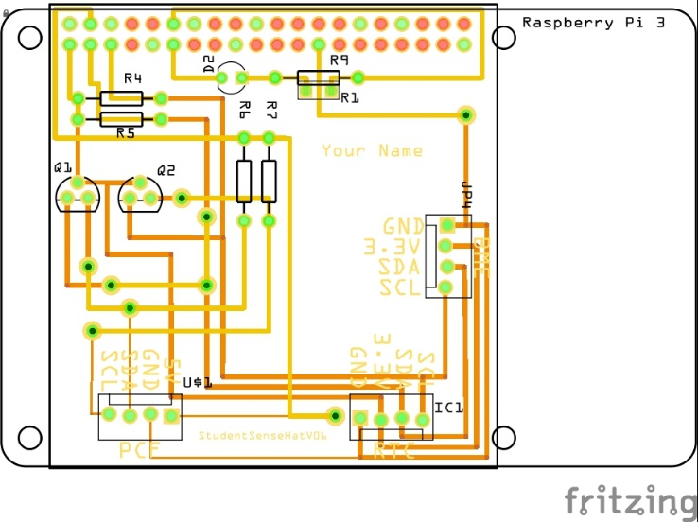

Figure 5. PCB design This work is a derivative of "http://fritzing.org/parts/" by Fritzing, used under CC:BY-SA 3.0.

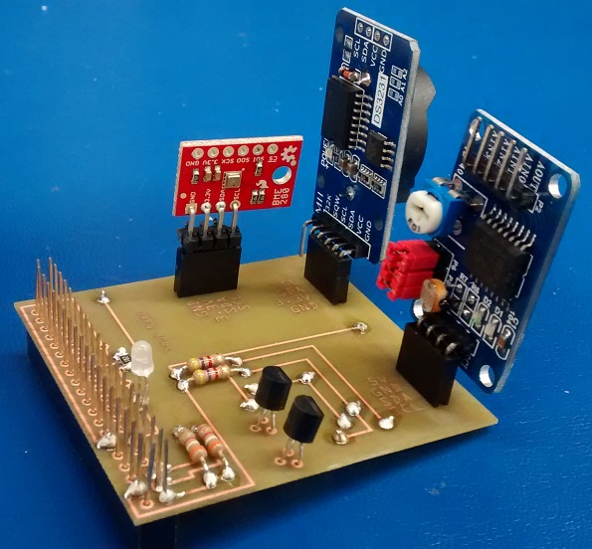

Figure 6. Humber Sense Hat Prototype PCB.

### 3.2.5 Enclosure

Demo

/1 Hardware present?

/1 Case encloses development platform and custom PCB.

/1 Appropriate parts securely attached.

/1 Appropriate parts accessible.

/1 Design file in repository, photo in report.

How did you build your Prototype: Case?

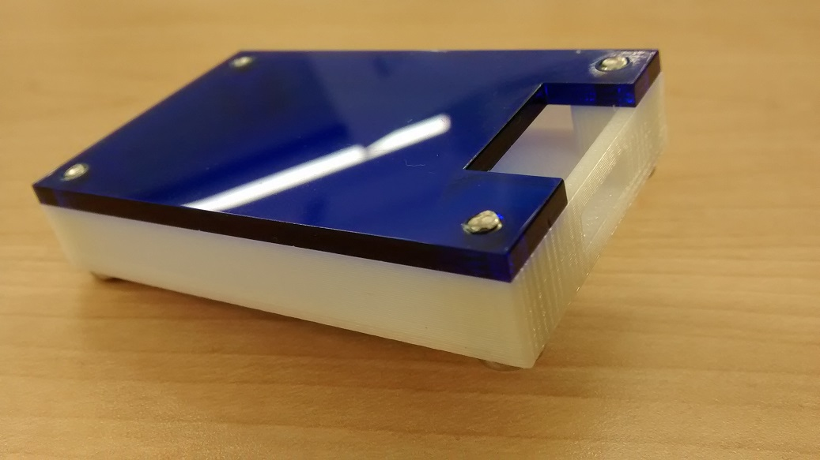

Figure 7. Example enclosure.

## 3.3 Integration

Demo

/1 Hardware present?

/1 Data sent by hardware

/1 Data retrieved by mobile application

/1 Action initiated by mobile application

/1 Action recieved by hardware

Report

/1 Enterprise wireless connectivity (250)

/1 Database configuration (250 words)

/1 Security considerations (500 words)

/1 Unit testing (900 words)

/1 Production testing (100 words)

### 3.3.1 Enterprise Wireless Connectivity

How did you make a Database accessible by both your Prototype and Mobile Application?

### 3.3.2 Database Configuration

### 3.3.3 Security

### 3.3.4 Testing

Unit testing and Production testing.

# 4.0 Results and Discussions

Is your prototype perfect? What did you learn?

# 5.0 Conclusions

If you were making 1000 of these.

Report

/1 Hardware present?

/1 Checklist truthful

/1 Valid Comments

/1 Results and Discussion (500 words)

/1 Conclusion

# 6.0 References

Bosch Sensortec. (2019, July). *BME680 - Datasheet.* Retrieved from Robert Bosch GmbH: https://ae-bst.resource.bosch.com/media/_tech/media/datasheets/BST-BME680-DS001.pdf

Kinsella, J. (2019). Five trends predicted for the cloud industry in 2019. *Software World*, 50(1), 11.

Media, O. (2019). *O'Reilly artificial intelligence conference 2019 - San Jose, California.* California: O'Reilly Media, Inc.

OACETT. (2017, March). *I need to Complete a Technology Report*. Retrieved from The Ontario Association of Certified Engineering Technicians and Technologists: https://www.oacett.org/Membership/Technology-Report-and-Seminar

Robuck, M. (2018, 11). AWS goes deep and wide with machine learning services and capabilities. *Fierceinstaller*.

# 7.0 Appendix

## 7.1 Firmware code

Demo

/1 Hardware present?

/3 Code runs concurrently for all sensors/effectors

/1 Project repository contains integrated code

Status

/1 Memo including updates

/1 Financial update

/1 Progress update

/1 Modified Code Files in Appendix

/1 Link to Complete Code in Repository

## 7.2 Application code

Demo

/1 Hardware present?

/1 Memo by student A

/1 Login activity

/1 Data visualization activity

/1 Action control activity

Report

/1 Login activity

/1 Data visualization activity

/1 Action control activity

/1 Modified Code Files in Appendix

/1 Link to Complete Code in Repository